SOFTWARE IMPLEMENTATION

OF A

SMART IRRIGATION SYSTEM

BY:

GROUP 1

DEPARTMENT OF MECHATRONICS ENGINEERING

MECHATRONICS SYSTEM DESIGN (MCE 413)

FEDERAL UNIVERSITY OF TECHNOLOGY, MINNA

FRIDAY, 7TH MARCH, 2025

Group members | Contribution
Emmanuel Israel Odeh | Python Programmer
Hameed Fodlullahi Abidemi | Report writer/Head researcher
James Emmanuel Nkeki | 3D designer
Abayomi Sunday Gabriel | UI/UX designer
Badmus Adams Okikiolamilekan | Web developer
Praise Yakubu | Documentation
Solomon Timothy | Design of Proteus simulation
Abu Sherif Gbenga | Documentation
Gideon Temidayo Ajayi | Documentation
Amodu Adeoluwa Omotolawa | Documentation

INTRODUCTION

Overview of Smart Irrigation and Its Importance
Agriculture is a vital sector that relies heavily on water for crop cultivation. Traditional irrigation methods often result in excessive water use, leading to wastage and inefficient resource management. Smart irrigation leverages modern technology, including sensor-based monitoring, automated control systems, and real-time data analytics, to optimize water usage. By integrating soil moisture sensors, weather data, and IoT-based control mechanisms, smart irrigation systems ensure efficient water distribution, improving crop yield while conserving water resources. This approach not only enhances agricultural sustainability but also mitigates the impact of climate change and water scarcity.

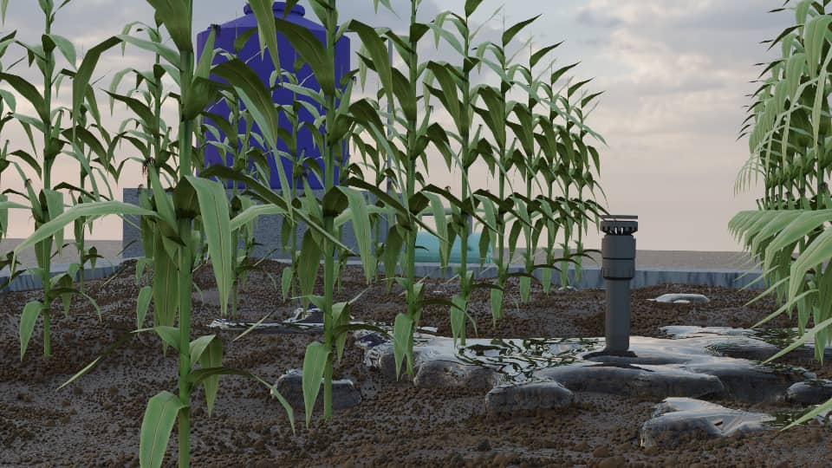
Figure 1: 3D Model of a simple irrigation system

Problem Statement and Objectives

Problem Statement
Conventional irrigation practices often lead to challenges such as over-irrigation, under-irrigation, inefficient water usage, and increased operational costs. Farmers lack real-time insights into soil moisture levels, weather conditions, and water needs, resulting in sub-optimal irrigation schedules. These inefficiencies can lead to crop stress, reduced yield, and depletion of groundwater resources. To address these issues, a smart, automated irrigation system is required to intelligently regulate water supply based on real-time environmental data.

Objectives
The primary objectives of this project are:
- To design and implement a Smart Irrigation System that efficiently manages water distribution using sensor-driven data and automation.
- To integrate real-time monitoring of soil moisture, temperature, humidity, and weather conditions to make informed irrigation decisions.
- To develop a control system that automates irrigation based on soil moisture thresholds and weather forecasts.
- To implement a visualization dashboard that provides real-time insights into soil conditions, irrigation schedules, and water consumption trends.
- To evaluate system performance by comparing water usage efficiency and crop health under smart irrigation versus traditional methods.

THEORETICAL BACKGROUND
Smart irrigation is an advanced precision agriculture technique that reduces water wastage and ensures optimal crop hydration. The system leverages evapotranspiration (ET) data, soil moisture sensors, and weather forecasts to determine irrigation needs. Theoretical concepts applied in this project include:

Soil Moisture
Soil moisture plays a critical role in determining irrigation needs. Sensors such as capacitive soil moisture sensors and tensiometers measure the volumetric water content in the soil. These sensors provide real-time data that helps in preventing over-irrigation or under-irrigation, ensuring crops receive adequate hydration while conserving water resources.

Automated Irrigation System
Automation in irrigation eliminates human intervention by using sensor-driven control mechanisms. When soil moisture levels drop below a predefined threshold, the system triggers irrigation automatically. Conversely, when moisture levels are sufficient, irrigation is halted, preventing excessive water use. Automated irrigation systems improve water efficiency and reduce manual labor requirements.

Sensor-Based Control Systems
Sensors are at the heart of smart irrigation. Various sensors such as soil moisture sensors, temperature sensors, humidity sensors, and rain gauges work together to monitor environmental conditions. The system processes this data using microcontrollers (Arduino UNO ) and embedded processors to make real-time irrigation decisions. This ensures that irrigation is precisely adjusted based on actual conditions rather than fixed schedules.

Data Processing for Water Management
Collected sensor data is processed and analyzed to optimize irrigation decisions. Machine learning algorithms, statistical analysis, and historical data trends help in predicting irrigation needs. The system can use cloud computing platforms to store and analyze data for improved decision-making, ensuring the efficient allocation of water resources.

Weather-Based Irrigation Control
Weather conditions significantly impact irrigation needs. The system integrates weather APIs (such as WeatherVisualCrossing) to obtain real-time weather forecasts, temperature, humidity, and precipitation levels. This data is used to adjust irrigation schedules dynamically. For instance, if rainfall is predicted, the system delays irrigation to conserve water.

IoT in Agriculture
IoT (Internet of Things) technology enhances the connectivity of irrigation systems. Wireless communication protocols VSPE enable remote monitoring and control of irrigation processes. Farmers can access real-time data and control irrigation systems via mobile applications or web dashboards, making smart irrigation more accessible and efficient.
METHODOLOGY

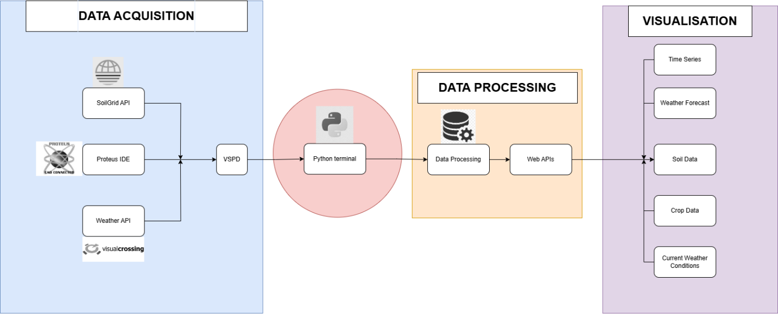
Figure 2: Block diagram for a smart irrigation system

System Design & Components
The Smart Irrigation System is designed to integrate multiple technologies for efficient water management. The system consists of the following components:
- Sensors: Soil moisture sensor, DHT11 (temperature & humidity), rain gauge, and wind speed sensor.
- Microcontroller: Arduino UNO for data processing and automation.
- Water Pump & Valves: Automated pumping system controlled via relays.
- Data Processing Unit: Python/Node.js for real-time data analytics.
- Dashboard: Web-based interface for monitoring soil conditions and water usage trends.

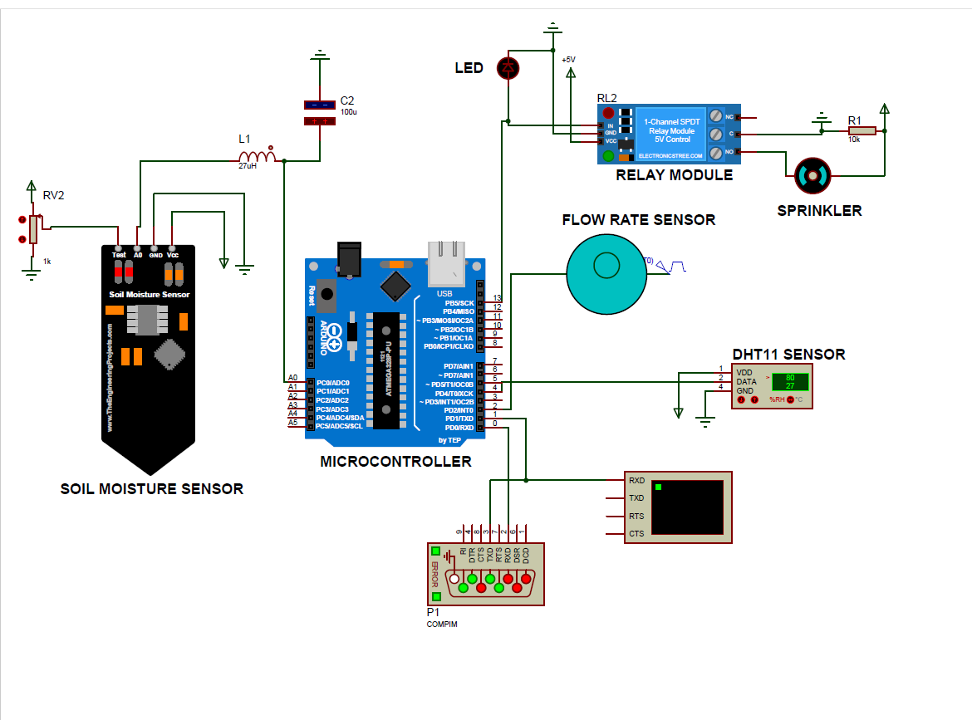
Figure 3 : Circuit Design

Implementation Steps
- Sensor Deployment: Sensors are installed in different soil types to collect real-time data on moisture, temperature, and weather conditions.
- Weather API Integration: The system retrieves real-time weather data from WeatherVisualCrossing to adjust irrigation schedules.
- Automation Algorithm Development: A decision-making algorithm is programmed to trigger irrigation only when soil moisture falls below a defined threshold.
- Communication Setup: The system uses VSPD for efficient remote data transfer and system control.
- Data Storage and Analysis: The collected data is processed and stored using cloud-based platforms for analysis and visualization.
- Dashboard Development: A user-friendly graphical interface is designed for real-time monitoring of soil conditions, weather trends, and irrigation status.
- Testing and Optimization: The system undergoes extensive testing under various environmental conditions to evaluate efficiency, water savings, and accuracy in predicting irrigation needs..

RESULTS
The software implementation of the Smart Irrigation System was successfully developed, integrating sensor data processing, automation control, and real-time visualization. The system effectively managed water distribution through a data-driven decision-making approach. Below are the key findings from testing and analysis.
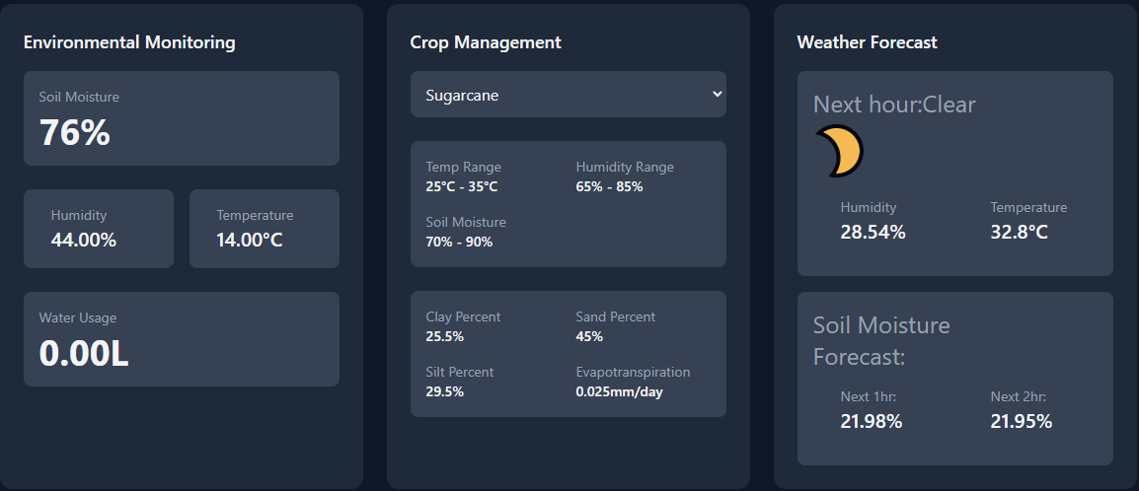
Figure 4: Dashboard

1. System Functionality and Performance
The software was evaluated based on core functionalities, including data acquisition, processing speed, automation logic, and user interface performance. The key results include:
Real-Time Data Processing:
- Sensor data (soil moisture, temperature, humidity) was received and processed within 2 seconds of transmission.
- The software efficiently interpreted moisture levels and triggered irrigation commands without delays.
Automation and Decision-Making:
  - The system autonomously activated irrigation when soil moisture dropped below predefined threshold which is dependent on crop type.
  - Weather API integration allowed the system to skip irrigation cycles during expected rainfall, reducing unnecessary water usage.
- Remote Monitoring
  - Users could access real-time soil conditions, irrigation status, and historical data through a web dashboard.

2. Data Visualization and User Interface Performance
The software featured a user-friendly interface with interactive graphs and trend analysis.
Figure 5: Data input and Data Processing

Dashboard Efficiency:
Soil moisture, temperature, humidity, and irrigation status were displayed in real-time with an update frequency of every 5 seconds.

3. Challenges and Optimizations
During testing, some challenges were encountered, and solutions were implemented:
- Inconsistent Weather API Calls: Occasionally, the OpenWeatherMap API failed to return data. Implemented an alternative API to provide reliable weather forecast.
- We encountered a difficulty integrating the proteus simulation with Python scripts. However, this issue was resolved using a Visual Serial Port Emulator (VSPE), a third party application.
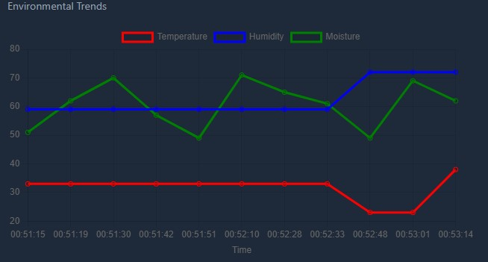
Figure 6: Environmental Trends Chart

REFERENCES

  - Saxton, K. E., & Rawls, W. J. (2006)
Soil water characteristic estimates by texture and organic matter for hydrologic solutions.
Soil Science Society of America Journal, 70(5), 1569–1578.
Used for: Estimating θ_sat (saturation), θ_fc (field capacity), and θ_wp (wilting point) from soil texture.

  - Cosby, B. J., Hornberger, G. M., Clapp, R. B., & Ginn, T. R. (1984)
A statistical exploration of the relationships of soil moisture characteristics to the physical properties of soils.
Water Resources Research, 20(6), 682–690.

  - Hargreaves-Samani ET₀
Source: Hargreaves, G.H., & Samani, Z.A. (1985).
Reference Crop Evapotranspiration from Temperature.
Source: Allen, R.G., et al. (1998).
Crop Evapotranspiration (FAO Paper 56).

  - Solar Geometry Calculations
Method: Duffie & Beckman (2013) solar position algorithm
Validation: Cross-checked with NREL's Solar Position Algorithm.

